CLINICIAN COPY
Patient Label
B12 Patient Home Administration
Agreement

Health Professional/Clinician
- The patient has consented to self-administer
- The patient is aware of the possible side effects and when to seek medical advice
- I have advised about the sharps bin and advised of local collection/disposal arrangements
- The patient will be provided with stock to do at home for 1 year:
X5 2ml syringes, X5 needles to draw up, X5 needles to administer
Signature by clinician:
Clinician Name:
............................................................................................................................................................
Patient
- I understand that the injection can be given by my doctor or nurse, or I can be taught how to inject myself
- I have chosen to learn how to inject myself
- I understand that I need one injection every 12 weeks and have been provided repeat prescriptions (if self-administering)

I will contact the surgery if I have any worries about injecting, particularly:
- Very painful or longer-lasting reactions at the injection site
- If I am worried I may not have given the injection correctly
If I have changed my mind and don’t want to give the injection myself
- Any other concerns I may have
- I understand the need to keep my sharps bin in a safe place and phone Chorley Council to organise a collection on 01257 515151
- You need small sharps bin which you can buy from most pharmacies.

Signature by patient:
............................................................................................................................................................

PATIENT COPY
Patient Label
B12 Patient Home Administration
Agreement
Health Professional/Clinician
- The patient has consented to self-administer
- The patient is aware of the possible side effects and when to seek medical advice
- I have advised about the sharps bin and advised of local collection/disposal arrangements
- The patient will be provided with stock to do at home for 1 year:
X5 2ml syringes, X5 needles to draw up, X5 needles to administer
Signature by clinician:
Clinician Name:
............................................................................................................................................................
Patient
- I understand that the injection can be given by my doctor or nurse, or I can be taught how to inject myself
- I have chosen to learn how to inject myself
- I understand that I need one injection every 12 weeks and have been provided repeat prescriptions (if self-administering)

I will contact the surgery if I have any worries about injecting, particularly:
- Very painful or longer-lasting reactions at the injection site
- If I am worried I may not have given the injection correctly
If I have changed my mind and don’t want to give the injection myself
- Any other concerns I may have
- I understand the need to keep my sharps bin in a safe place and phone Chorley Council to organise a collection on 01257 515151
- You need small sharps bin which you can buy from most pharmacies.

Signature by patient:
............................................................................................................................................................

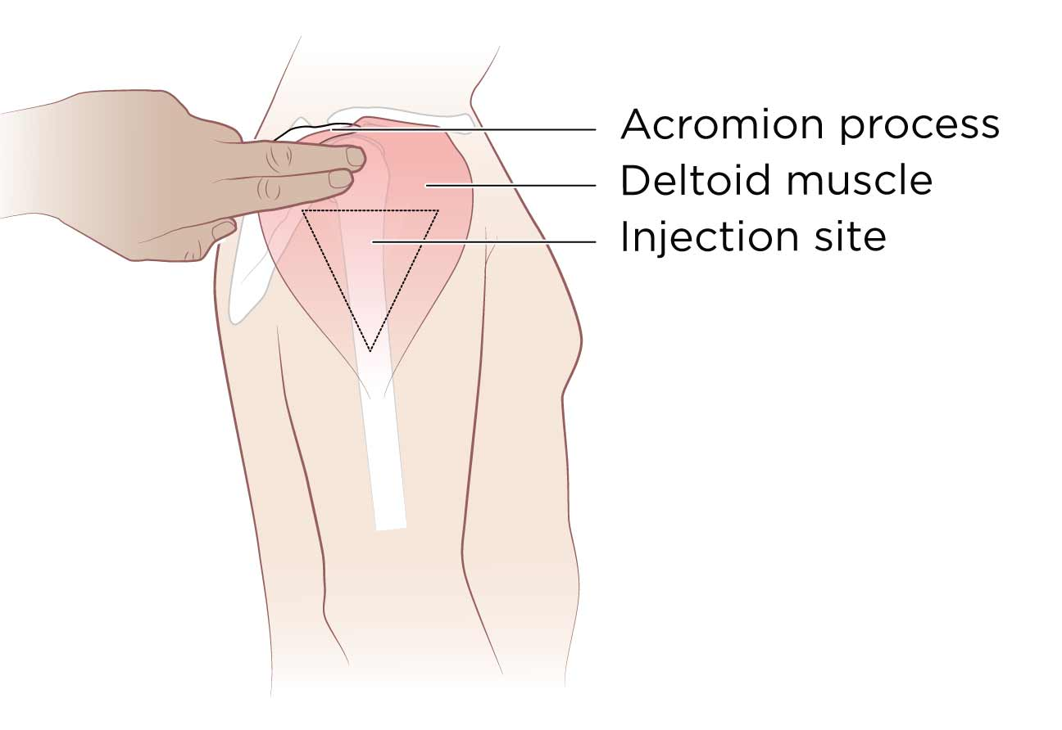
B12 Patient Diary
Name:
Date of birth:
Address:

- Ensure you have a clean surface to prepare your injection
- Ensure the skin on the injection site is clean
- Wash your hands
- At a 90 degree angle insert the injection and press slowly till empty
- Withdraw the needle and put straight in sharps bin
- Cover injection site with plaster or press with gauze for at least 30 seconds
Date | Arm (alternate) | Expiry | Batch Number | Next Due

When this diary is complete you can return it to the surgery to be scanned in your record and we can provide you with a new sheet.

